**Laporan Hasil Praktikum HTML, CSS, JAVASCRIPT**



Nama :

Abdurrahman Ali

**SMK NEGERI 50 JAKARTA**

Jl. Cipinang Muara I Jatinegara Jakarta Timur 13240 Tlp/Fax : 021-8194466

Website : [www.smk50jkt.sch.id](http://www.smk50jkt.sch.id) – Email: [smk_limapuluh@yahoo.com](mailto:smk_limapuluh@yahoo.com)

1. **Tema Website**

Pada bagian ini Anda akan menjelaskan alasan mengapa Anda menggunakan tema tersebut sebagai pengambilan nilai Tugas Akhir Website untuk maple DMI. Pada bagian ini tampilkan juga gambar storyboard website kalian atau flowchart website kalian.

1. **Source code index**

<!doctype html>

<html lang="en">

<head>

<!-- Required meta tags -->

<meta charset="utf-8">

<meta name="viewport" content="width=device-width, initial-scale=1, shrink-to-fit=no">

<!-- Bootstrap CSS -->

<link rel="stylesheet" href="https://stackpath.bootstrapcdn.com/bootstrap/4.4.1/css/bootstrap.min.css" integrity="sha384-Vkoo8x4CGsO3+Hhxv8T/Q5PaXtkKtu6ug5TOeNV6gBiFeWPGFN9MuhOf23Q9Ifjh" crossorigin="anonymous">

<title>Hello, world!</title>

</head>

<body>

<nav class="navbar navbar-expand-lg navbar-dark bg-success">

<a class="navbar-brand" href="#">Navbar</a>

<button class="navbar-toggler" type="button" data-toggle="collapse" data-target="#navbarNavDropdown" aria-controls="navbarNavDropdown" aria-expanded="false" aria-label="Toggle navigation">

<span class="navbar-toggler-icon"></span>

</button>

<div class="collapse navbar-collapse" id="navbarNavDropdown">

<ul class="navbar-nav">

<li class="nav-item active">

<a class="nav-link" href="#">Home <span class="sr-only">(current)</span></a>

</li>

<li class="nav-item">

<a class="nav-link" href="#">Features</a>

</li>

<li class="nav-item">

<a class="nav-link" href="#">Pricing</a>

</li>

<li class="nav-item dropdown">

<a class="nav-link dropdown-toggle" href="#" id="navbarDropdownMenuLink" role="button" data-toggle="dropdown" aria-haspopup="true" aria-expanded="false">

Dropdown link

</a>

<div class="dropdown-menu" aria-labelledby="navbarDropdownMenuLink">

<a class="dropdown-item" href="#">Action</a>

<a class="dropdown-item" href="#">Another action</a>

<a class="dropdown-item" href="#">Something else here</a>

</div>

</li>

</ul>

</div>

</nav>

<!-- Optional JavaScript -->

<!-- jQuery first, then Popper.js, then Bootstrap JS -->

<script src="https://code.jquery.com/jquery-3.4.1.slim.min.js" integrity="sha384-J6qa4849blE2+poT4WnyKhv5vZF5SrPo0iEjwBvKU7imGFAV0wwj1yYfoRSJoZ+n" crossorigin="anonymous"></script>

<script src="https://cdn.jsdelivr.net/npm/popper.js@1.16.0/dist/umd/popper.min.js" integrity="sha384-Q6E9RHvbIyZFJoft+2mJbHaEWldlvI9IOYy5n3zV9zzTtmI3UksdQRVvoxMfooAo" crossorigin="anonymous"></script>

<script src="https://stackpath.bootstrapcdn.com/bootstrap/4.4.1/js/bootstrap.min.js" integrity="sha384-wfSDF2E50Y2D1uUdj0O3uMBJnjuUD4Ih7YwaYd1iqfktj0Uod8GCExl3Og8ifwB6" crossorigin="anonymous"></script>

</body>

</html>

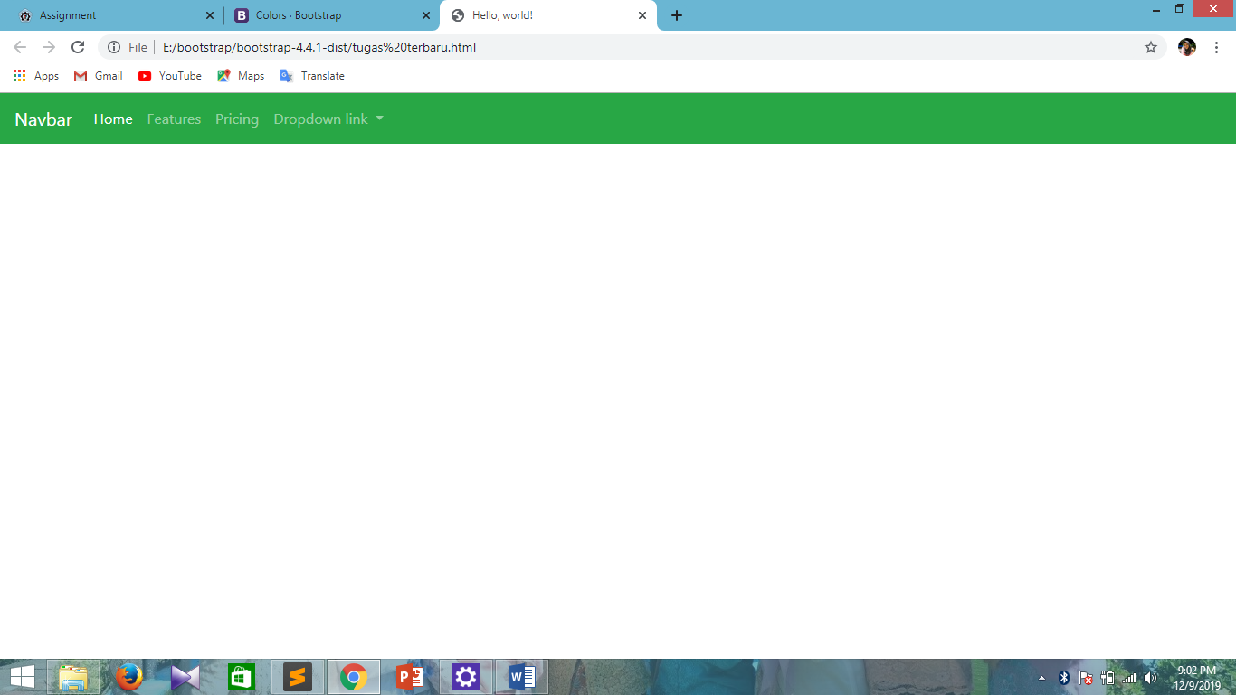

1. **Source code penggunaan CSS**

<!doctype html>

<html lang="en">

<head>

<!-- Required meta tags -->

<meta charset="utf-8">

<meta name="viewport" content="width=device-width, initial-scale=1, shrink-to-fit=no">

<!-- Bootstrap CSS -->

<link rel="stylesheet" href="https://stackpath.bootstrapcdn.com/bootstrap/4.4.1/css/bootstrap.min.css" integrity="sha384-Vkoo8x4CGsO3+Hhxv8T/Q5PaXtkKtu6ug5TOeNV6gBiFeWPGFN9MuhOf23Q9Ifjh" crossorigin="anonymous">

<title>Hello, world!</title>

</head>

<body>

<div class="jumbotron">

<h1 class="display-4">Hello, world!</h1>

<p class="lead">This is a simple hero unit, a simple jumbotron-style component for calling extra attention to featured content or information.</p>

<hr class="my-4">

<p>It uses utility classes for typography and spacing to space content out within the larger container.</p>

<a class="btn btn-primary btn-lg" href="#" role="button">Learn more</a>

</div>

<!-- Optional JavaScript -->

<!-- jQuery first, then Popper.js, then Bootstrap JS -->

<script src="https://code.jquery.com/jquery-3.4.1.slim.min.js" integrity="sha384- J6qa4849blE2+poT4WnyKhv5vZF5SrPo0iEjwBvKU7imGFAV0wwj1yYfoRSJoZ+n" crossorigin="anonymous"></script>

<script src="https://cdn.jsdelivr.net/npm/popper.js@1.16.0/dist/umd/popper.min.js" integrity="sha384- Q6E9RHvbIyZFJoft+2mJbHaEWldlvI9IOYy5n3zV9zzTtmI3UksdQRVvoxMfooAo" crossorigin="anonymous"></script>

<script src="https://stackpath.bootstrapcdn.com/bootstrap/4.4.1/js/bootstrap.min.js" integrity="sha384- wfSDF2E50Y2D1uUdj0O3uMBJnjuUD4Ih7YwaYd1iqfktj0Uod8GCExl3Og8ifwB6" crossorigin="anonymous"></script>

</body>

</html>

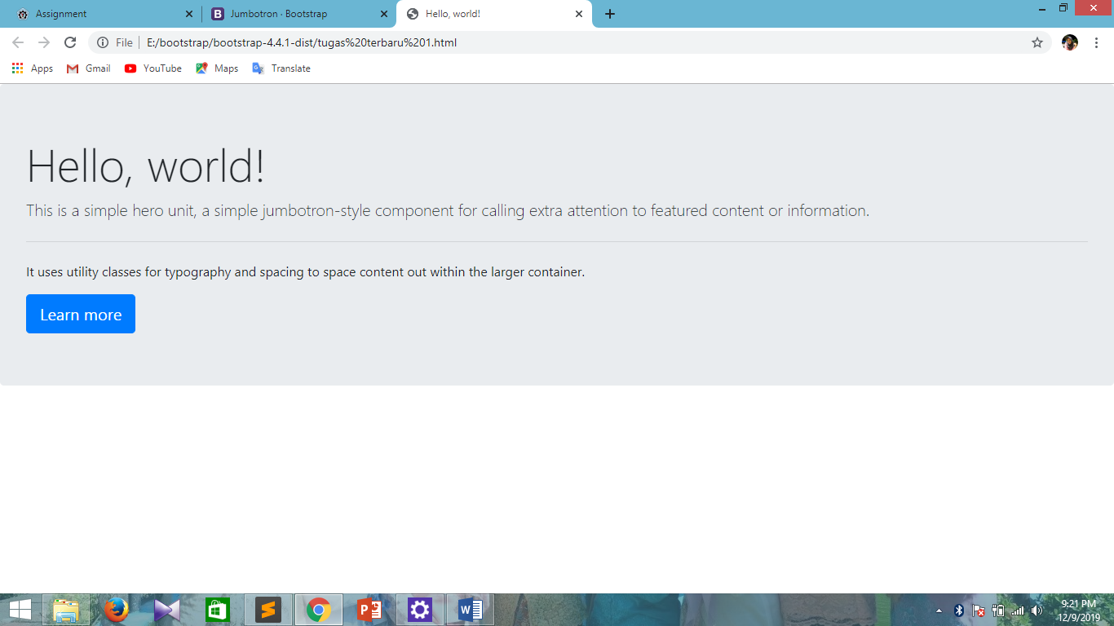

1. **Source code penggunaan Javascript**

<!doctype html>

<html lang="en">

<head>

<!-- Required meta tags -->

<meta charset="utf-8">

<meta name="viewport" content="width=device-width, initial-scale=1, shrink-to-fit=no">

<!-- Bootstrap CSS -->

<link rel="stylesheet" href="https://stackpath.bootstrapcdn.com/bootstrap/4.4.1/css/bootstrap.min.css" integrity="sha384-Vkoo8x4CGsO3+Hhxv8T/Q5PaXtkKtu6ug5TOeNV6gBiFeWPGFN9MuhOf23Q9Ifjh" crossorigin="anonymous">

<title>Hello, world!</title>

</head>

<body>

<div id="carouselExampleIndicators" class="carousel slide" data-ride="carousel">

<ol class="carousel-indicators">

<li data-target="#carouselExampleIndicators" data-slide-to="0" class="active"></li>

<li data-target="#carouselExampleIndicators" data-slide-to="1"></li>

<li data-target="#carouselExampleIndicators" data-slide-to="2"></li>

</ol>

<div class="carousel-inner">

<div class="carousel-item active">

<img src="nabila.PNG" class="d-block w-100" alt="...">

</div>

<div class="carousel-item">

<img src="nabila.PNG" class="d-block w-100" alt="...">

</div>

<div class="carousel-item">

<img src="nabila.PNG" class="d-block w-100" alt="...">

</div>

</div>

<a class="carousel-control-prev" href="#carouselExampleIndicators" role="button" data-slide="prev">

<span class="carousel-control-prev-icon" aria-hidden="true"></span>

<span class="sr-only">Previous</span>

</a>

<a class="carousel-control-next" href="#carouselExampleIndicators" role="button" data-slide="next">

<span class="carousel-control-next-icon" aria-hidden="true"></span>

<span class="sr-only">Next</span>

</a>

</div>

<!-- Optional JavaScript -->

<!-- jQuery first, then Popper.js, then Bootstrap JS -->

<script src="https://code.jquery.com/jquery-3.4.1.slim.min.js" integrity="sha384-J6qa4849blE2+poT4WnyKhv5vZF5SrPo0iEjwBvKU7imGFAV0wwj1yYfoRSJoZ+n" crossorigin="anonymous"></script>

<script src="https://cdn.jsdelivr.net/npm/popper.js@1.16.0/dist/umd/popper.min.js" integrity="sha384-Q6E9RHvbIyZFJoft+2mJbHaEWldlvI9IOYy5n3zV9zzTtmI3UksdQRVvoxMfooAo" crossorigin="anonymous"></script>

<script src="https://stackpath.bootstrapcdn.com/bootstrap/4.4.1/js/bootstrap.min.js" integrity="sha384-wfSDF2E50Y2D1uUdj0O3uMBJnjuUD4Ih7YwaYd1iqfktj0Uod8GCExl3Og8ifwB6" crossorigin="anonymous"></script>

</body>

</html>

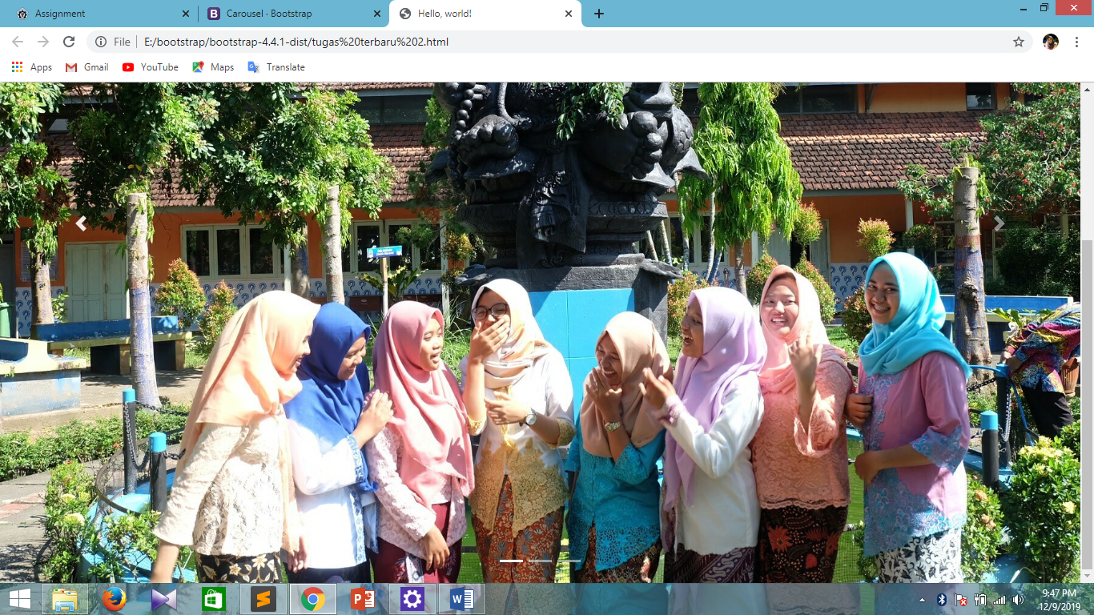

1. **Source code penggunaan Gambar, Video, dan Audio**

<!doctype html>

<html lang="en">

<head>

<!-- Required meta tags -->

<meta charset="utf-8">

<meta name="viewport" content="width=device-width, initial-scale=1, shrink-to-fit=no">

<!-- Bootstrap CSS -->

<link rel="stylesheet" href="https://stackpath.bootstrapcdn.com/bootstrap/4.4.1/css/bootstrap.min.css" integrity="sha384-Vkoo8x4CGsO3+Hhxv8T/Q5PaXtkKtu6ug5TOeNV6gBiFeWPGFN9MuhOf23Q9Ifjh" crossorigin="anonymous">

<title>Hello, world!</title>

</head>

<body>

<div class="container">

<div class="row">

<div class="col-sm bg-warning">

NABILA

</div>

<div class="col-sm bg-light">

ARISTA

</div>

<div class="col-sm bg-warning">

PUTRI

</div>

</div>

</div>

<!-- Optional JavaScript -->

<!-- jQuery first, then Popper.js, then Bootstrap JS -->

<script src="https://code.jquery.com/jquery-3.4.1.slim.min.js" integrity="sha384-J6qa4849blE2+poT4WnyKhv5vZF5SrPo0iEjwBvKU7imGFAV0wwj1yYfoRSJoZ+n" crossorigin="anonymous"></script>

<script src="https://cdn.jsdelivr.net/npm/popper.js@1.16.0/dist/umd/popper.min.js" integrity="sha384-Q6E9RHvbIyZFJoft+2mJbHaEWldlvI9IOYy5n3zV9zzTtmI3UksdQRVvoxMfooAo" crossorigin="anonymous"></script>

<script src="https://stackpath.bootstrapcdn.com/bootstrap/4.4.1/js/bootstrap.min.js" integrity="sha384-wfSDF2E50Y2D1uUdj0O3uMBJnjuUD4Ih7YwaYd1iqfktj0Uod8GCExl3Og8ifwB6" crossorigin="anonymous"></script>

</body>

</html>

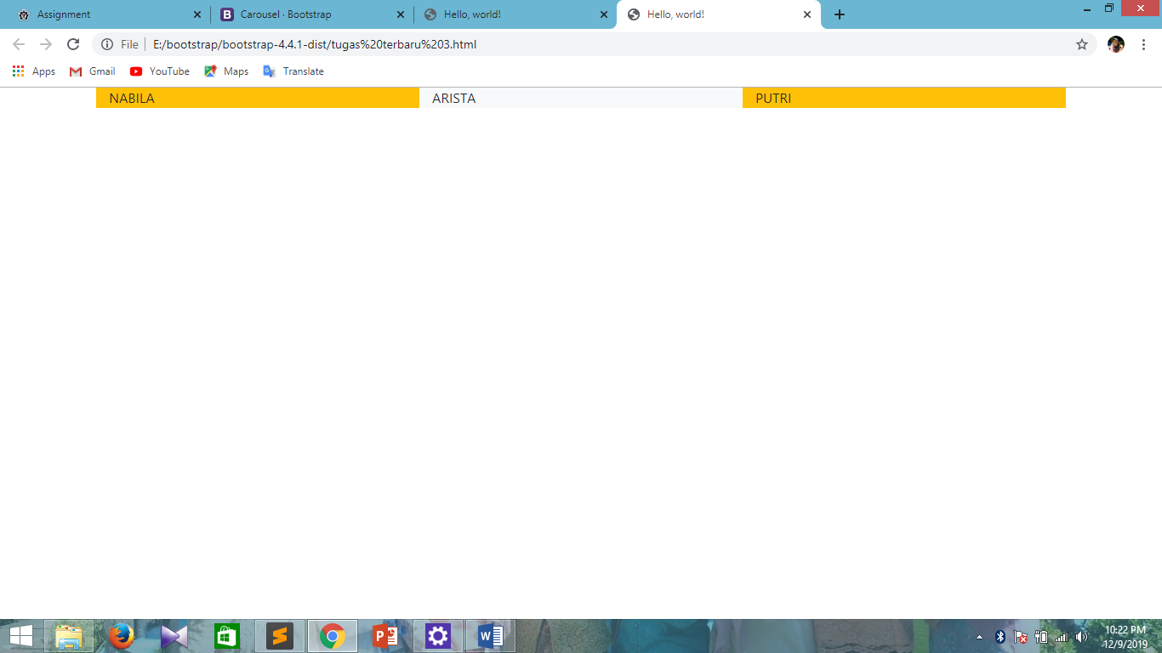

1. **Tuliskan dan jelaskan (berikan analisis) mengenai Perbedaan dan kesulitan pembuatan website dengan menggunakan Hard Coding (Ngoding sendiri) atau dengan menggunakan template. (berikan analisis minimal 2 paragraf dengan 1 paragraf minimal menggunakan 5 kalimat)**

Bagian bagian yang sulit :

* Saya masih kurang memahami bagaimana fungsi fungsi pada penggunaan bootstrapnya karena saya belom memahami tentang bootstrap lebih dalam
* Saya belom paham pada penggunaan bootstrap pada beberapa poinnya